**Investigation of Electric Fields**

**Jin Hyung Park**

**2021.06.11**

**SPH4U**

**Question.**

***How is the magnitude of the electric field affected by the distance from the source?***

***V*ariables.**

* Independent: The distance between the source and the charge was the independent variable in this lab.
* Dependent: The size of the electric field served as the dependent variable in this experiment.
* Controlled: In this lab, the controlled variable was the charge, which was + 1nC.

**Hypothesis.**

The electric field's strength or intensity is determined by the charged item's charge and the distance between it and the charged item. The distance at the denominator is included in the calculation for the electric field, which is . This indicates that the field strength and the distance are inversely proportional. As the distance between the source and the observer grows, the size of the electric field decreases.

### **Procedure.**

1. Open the simulation.Select the following options:
   1. Electric Field
   2. Grid
   3. Values
2. Drag the tape measure to the workspace.
3. Place a + 1 nC (1 nanoCoulomb) charge somewhere near the centre of the grid. The simulation uses short, shaded arrows to represent the field. Instead, sketch the electric field using SOLID lines with arrows to represent the field. Sketch a diagram of the resulting electric field.
4. Beginning again with an empty screen, place a -1 nC charge near the centre of the grid. Sketch the electric field using SOLID lines with arrows to represent the field. Sketch a diagram of the resulting electric field.
5. Beginning again with an empty screen, place two +1 nC charges horizontally separated by 1 m (100 cm) near the centre of the grid. Draw the resulting pattern using SOLID lines with arrows. Using the E-field Sensor, find a location where the field has a magnitude of 0. Sketch a diagram of the resulting electric field. (Note: The simulation uses units of V/m to represent the magnitude of the field. 1 V/m= 1N/C)
6. Remove all charges from the previous step. Place a +1 nC charge near the centre of the screen. Using the E-field sensor, determine the magnitude and direction of the field at a point that is 1 m to the right and 1.5 m up from the point charge (ie. a point whose coordinates are (1, 1.5), where the point charge is (0, 0)). Record the magnitude and direction of the field at that location.
7. Using the point charge from the previous step, use the E-Field Sensor to record the magnitude of the field at distances of 0.5, 1.0, 1.5, 2.0 and 2.5 m from the charge. Record the magnitude of the fields at the various positions in a table.

**Observations.**

**Figure 1. When charge was placed at the center of the grid.**

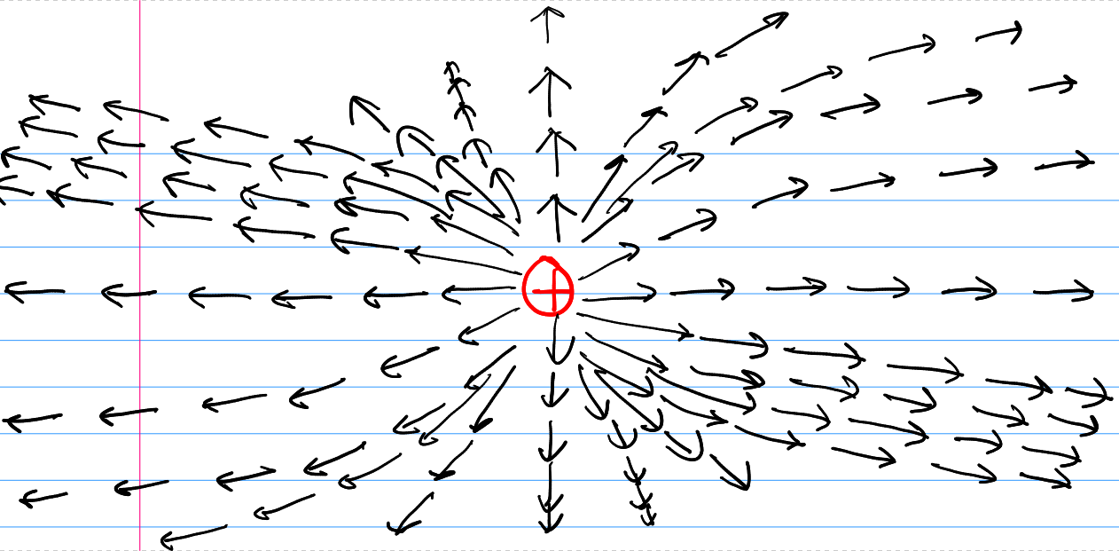

When a + 1 nano Coulomb charge was placed at the center of the grid shown above, the arrow points - which is the line of electric force - outwards. The electric field was opposite from the charge. From the image above, the points become blurry as they go much outwards since the electric field becomes weaker as the distance from the charge increases.

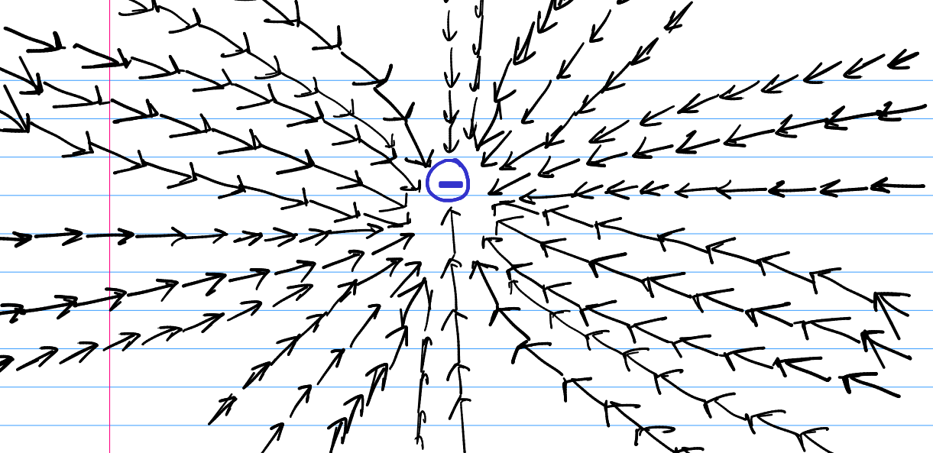

**Figure 2. When charge was placed at the center of the grid.**

When a - 1 nanoCoulomb charge was placed at the center of the grid shown above, the arrow points - which is the line of electric force - inwards. The electric field was opposite from the charge. From the image above, the points become stronger as they go much inwards since the electric field becomes stronger as the distance from the charge decreases.

**Figure 3. When 2 + charge was placed horizontally separated by 1m near the center of the grid.**

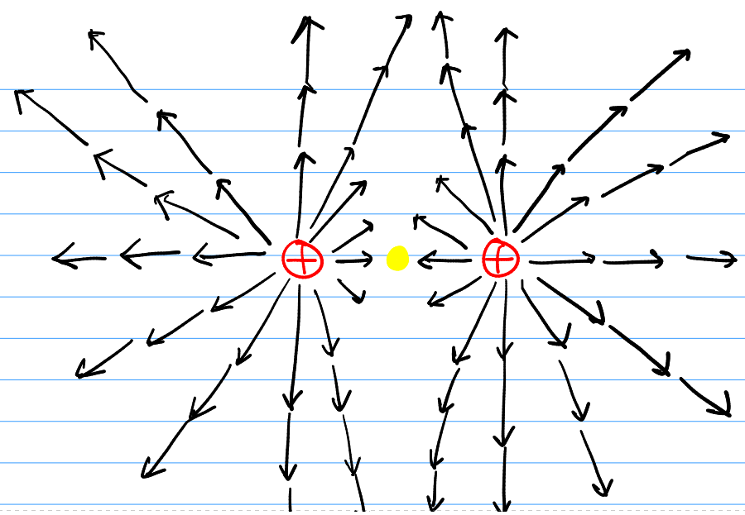

When 2 + 1 nanoCoulomb charges were placed 1m apart from the center of the grid, the arrow points outwards. Since two charges repel, the arrow points spread outwards and do not meet each other. The E-field sensor could spot a location where the midpoint of two charges, which had a magnitude of 0 and 0.5m away from each charge between two charges.

**Figure 4. When charge was placed at the center of the screen with the E-field sensor at a point that was 1m to the right and 1.5m up from the point charge (i.e. a point whose coordinates were (1, 1.5)).**

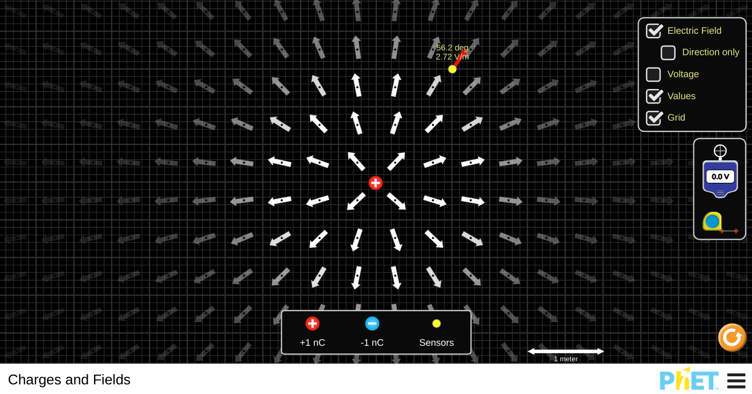

When the E-field sensor was placed 1m to the right and 1.5m up from the point charge, the magnitude was about with the direction of .

**Figure 5. When the E-field sensor was 0.5m away from the point charge.**

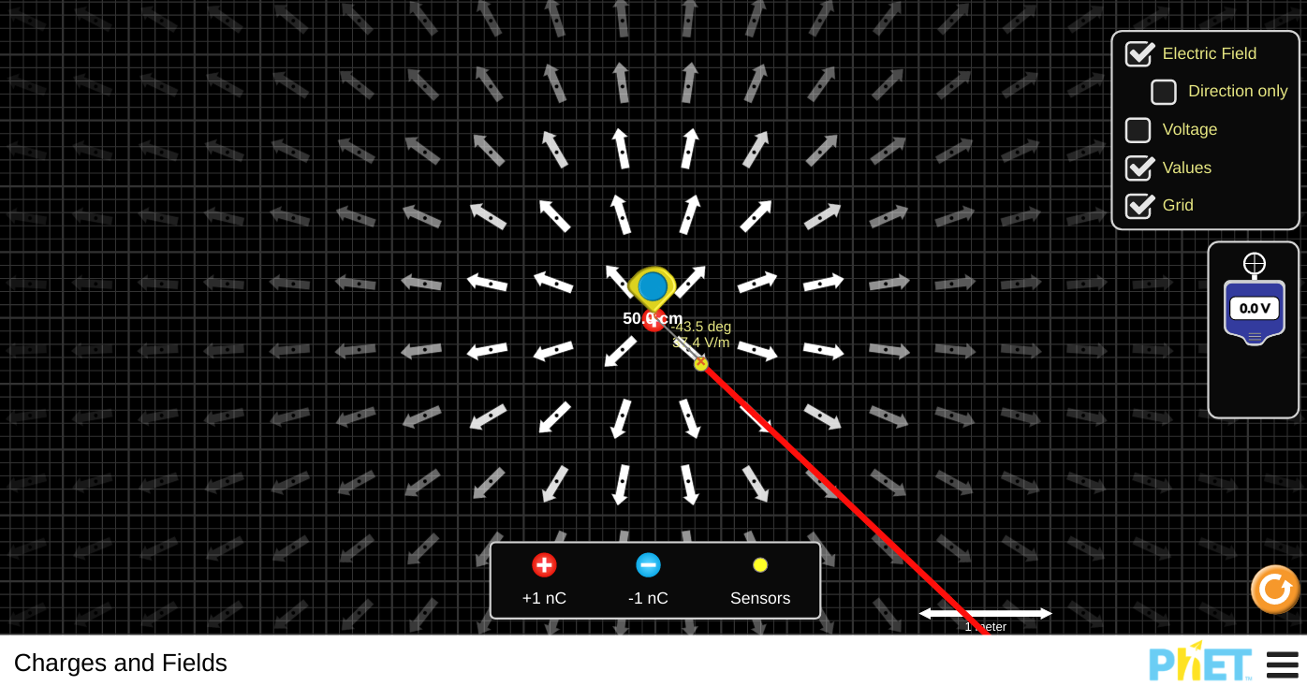

When the E-field sensor was 0.5m away from the point charge, the magnitude recorded was about with the direction being ignored.

**Figure 6. When the E-field sensor was 1.0m away from the point charge**

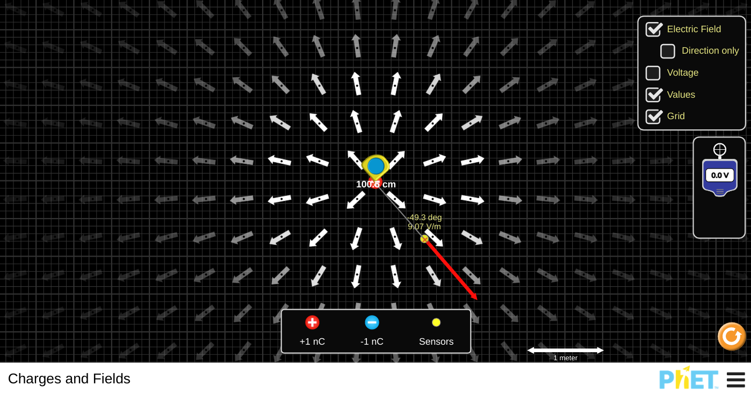

When the E-field sensor was about 1.0m away from the point charge, the magnitude that was recorded was about with the direction being ignored.

**Figure 7. When the E-field sensor was 1.5m away from the point charge**

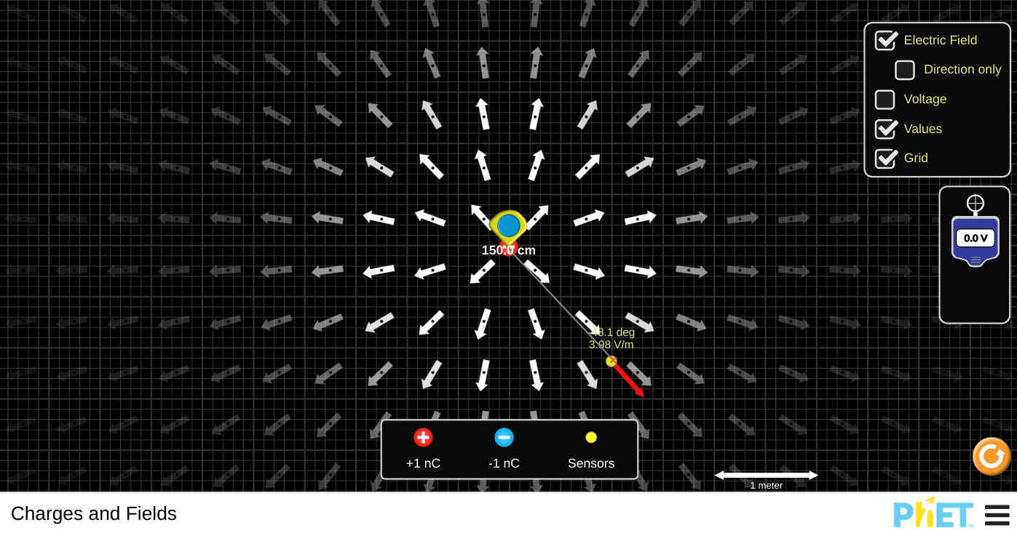

When the E-field sensor was 1.5m away from the point charge, the magnitude recorded was about with the direction being ignored.

**Figure 8. When the E-field sensor was 2.0m away from the point charge**

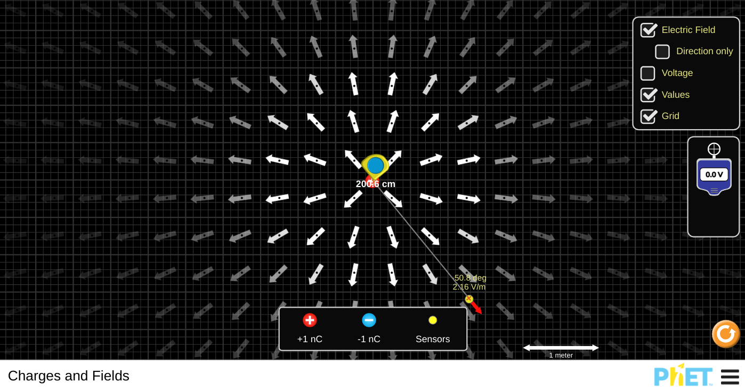

When the E-field sensor was about 2.0m away from the point charge, the magnitude recorded was about with the direction being ignored.

**Figure 8. When the E-field sensor was 2.5m away from the point charge**

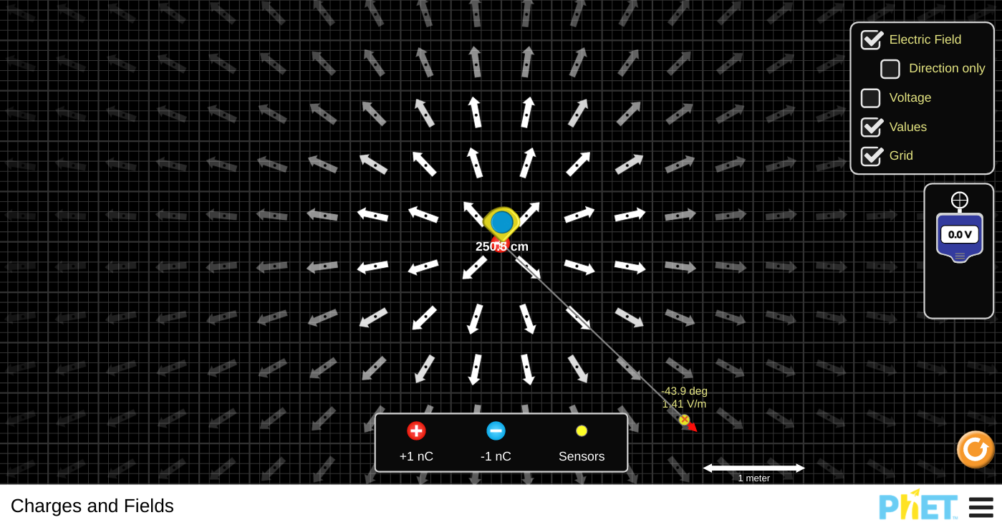

When the E-field sensor was 2.5m away from the point charge, the magnitude that was recorded was about with the direction being ignored.

**Results:**

The direction and magnitude when charge was placed at the center of the screen with the E-field sensor at a point that was 1m to the right and 1.5m up from the point charge (i.e. a point whose coordinates were (1, 1.5))

|  |  |
| --- | --- |
| **Direction** | **Magnitude** |
|  |  |

The magnitude of the field at distances of 0.5, 1.0, 1.5, 2.0 and 2.5 from the charge.

|  |  |  |
| --- | --- | --- |
| Distance | Magnitude | Distance^2 X Magnitude |
| 0.5m | 37.4V/m | 9.35 |
| 1.0m | 9.07V/m | 9.07 |
| 1.5m | 3.98V/m | 8.95 |
| 2.0m | 2.16V/m | 8.64 |
| 2.5m | 1.41V/m | 8.81 |

**Discussion.**

1. **What effect does the SIGN of the central charge have on the magnitude of the electric field and the direction of the electric field?**

The size of the electric field was unaffected by the sign of the center charge. The magnitudes remained constant regardless of the sign. The magnitude of the electric field between the two charges did not change since no other circumstances affected its intensity or magnitude. The magnitude of both + 1nC and -1nC was 1, indicating that the vector field did not change in size. The direction of the electric field, however, was affected by the sign of the center charge. When the central charge was + 1nC, the electric field was directed away from the charge, and when the charge was 1nC, the field was directed toward the charge.

Because the electric field is a vector quantity, the direction of the field is determined by the direction of a positive test charge when placed in it. This meant that the positive test charge would resist the + 1nC charge while being attracted to the -1nC charge. The field direction was likewise found to be away from + 1nC, whereas it was toward 1nC, based on the observations.

1. **In step #3, you found a location where the electric field was 0. Why is the field 0 at that location?**

The place where the electric field was zero was the intersection of the two opposing electric field vectors. There were two + 1nCs that were 1.0 m apart, indicating that the fields had spread out and repelled each other. The opposing fields' magnitudes were the same, but the direction was the polar opposite. To be cancelled, the directions required to be opposite, negative and positive. The electric field was zero as the sum of two vectors reached zero when the sensor was on the halfway of the two horizontally positioned + 1nC charges.

1. **In step #5, you found the magnitude and direction of the field at a specific location. Using formulae from the Content section of this course, determine these values theoretically. What percentage error in the magnitude of the field did you have using the simulation? Suggest reasons why an error might occur.**

From the + 1nC, the E-field sensor was placed 1.0 m to the right and 1.5 m to the top. The direction read 56.2° with a magnitude of 2.72V/m when the sensor was located.

* Theoretical value for direction.

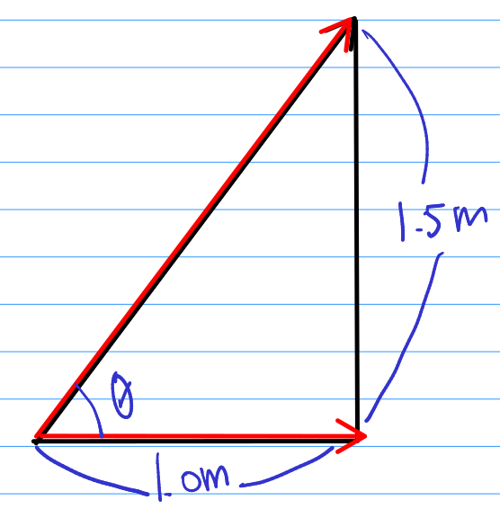

2

* Theoretical value for magnitude
* Percentage Error
* Error Analysis

The discrepancy might be due to the fact that the location of the E-field sensor was dependent on the experimenter's eyes. The exact spot (1, 1. 5) could not be found when the lab was almost completed. Instrumental measurement error, often known as intuition and sight, made it practically difficult to set the sensor in the correct location. As a result, the error rate was around 1.1 percent.

1. **Using the results from step #6, plot a graph of Electric field vs distance. After viewing the graph, suggest a mathematical relationship of how the Electric field varies with distance from the charge.**

Graph below shows the relationship between the electric field and distance from the data shown above.

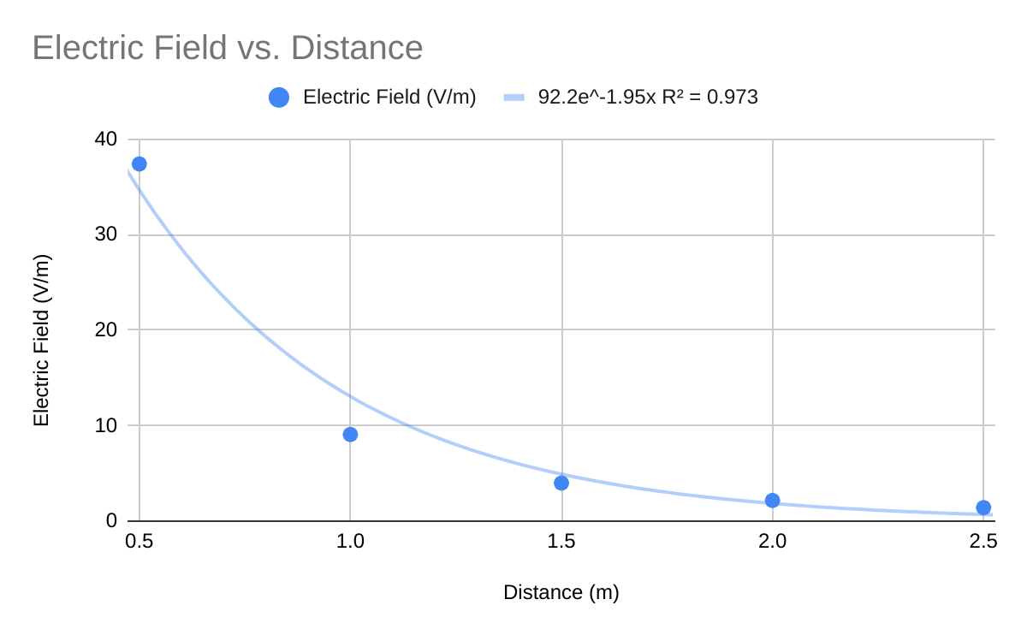

The graph resembles the inverse-square connection graphs in appearance. It was clear from the equation, , that the electric field and the distance had an inverse-square connection. When considering as the coefficient of inverse-square proportionally, we can think of the equation as .

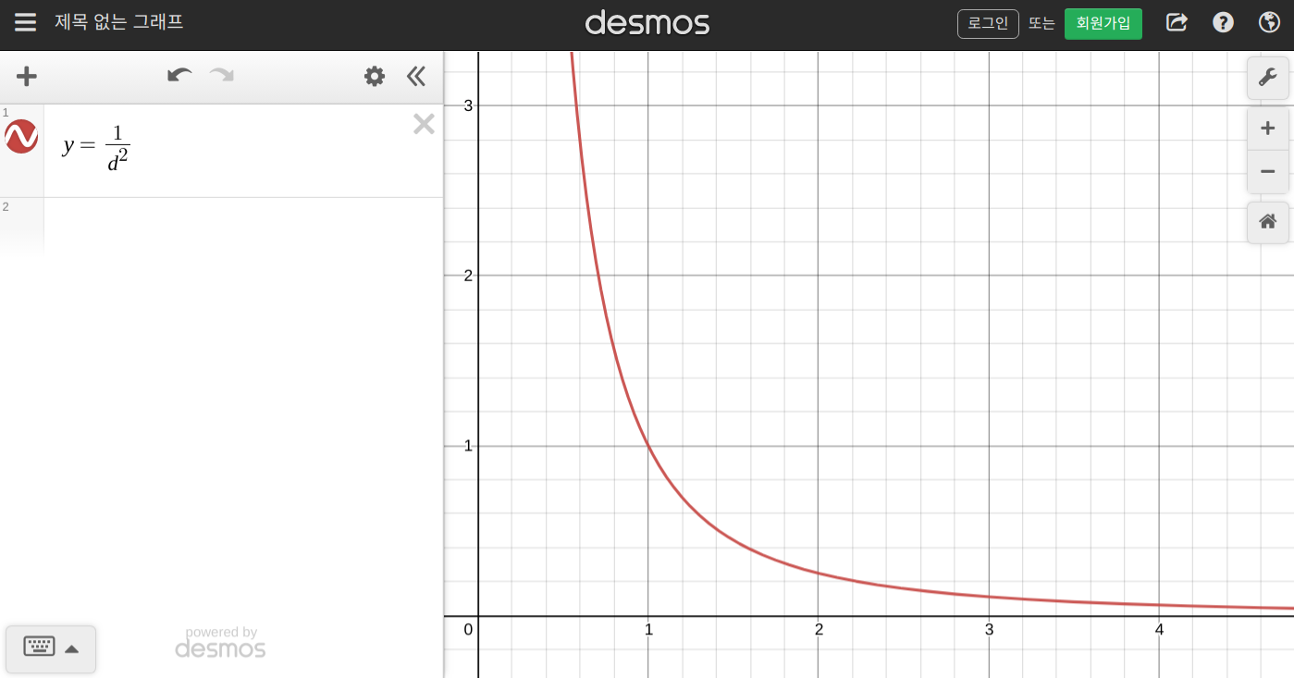

When the Graph of Electric Fields vs Magnitude and the graph right above were compared, the form appeared to be extremely similar. Because the electric field and distance are inversely proportional, the lower the electric field, the longer the distance. The size of the electric field grew dramatically when the distance was extremely near to the point charge, but gradually reduced as the distance rose.

The trendline for the graph was produced at the same time as Graph 1. The trendline was a power series trendline, with a R of 1 for the regression value. This meant that two of the experiment's data points were quite near to the curve's real trendline. Thus, we can confidently argue that the experiment was successful.

**Conclusion.**

The link between the amplitude of the electric field and the distance from the source was discovered in this lab experiment, which was a success. The hypothesis was right in that the strength of the field and the distance are inverse-square proportion since the distance is in the equation's denominator. The size of the electric field was inverse-square proportional to the distance away from the source, according to the experiment and equation. This meant that as the distance between the source and the force rose, the electric field decreased.

**References.**

Works Cited

“Electric Field: Concept of a Field Revisited | Physics.” *Courses.lumenlearning.com*, courses.lumenlearning.com/physics/chapter/18-4-electric-field-concept-of-a-field-revisited/.

“Physics Tutorial: Electric Field and the Movement of Charge.” *Www.physicsclassroom.com*, www.physicsclassroom.com/class/circuits/Lesson-1/Electric-Field-and-the-Movement-of-Charge.